UN Security Council
Model United Nations
Innlandet 2024

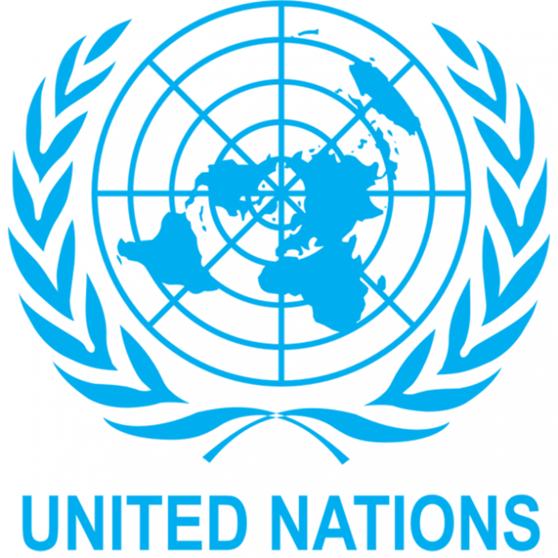
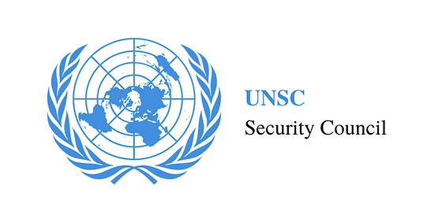
The Israel Lebanon conflict
Chairs: Torbjørn Waldemar & Victoria Alexandra Aas

Distinguished Delegates,
We wish you the warmest welcome to our third annual INMUN conference: As this year’s Security Council chairs, it is our role to introduce you to the committee, the topic and issue, and provide you with basic information, which you will find in this report. Also, we would like you to know that you can approach us concerning anything and everything - we are here to make your experience memorable!
This committee will be debating the ongoing Israel-Lebanon conflict. The reason we chose the topic is mainly its urgency and relevance in the world. This conflict has lasted for over 40 years and has cost many lives. This is a real crisis, and as Model United Nations delegates, we hope that your resolutions will bring about possible courses of action and solutions.
We thank you for attending our conference and choosing to be a part of this committee. We sincerely hope that you will enjoy your time with us, and that the work we do will be successful.
If you have any questions, you can always contact us via our email addresses:
torbjorn.waldemar@gmail.com
victoriajinming@gmail.com
Best wishes,
Torbjørn Waldemar, UNSC Chair
Victoria Alexandra Aas, UNSC Chair

About the Security Council
The United Nations Security Council (UNSC) is one of the six principal organs of the United Nations and is charged with ensuring international peace and security, recommending the admission of new UN members to the General Assembly, and approving any changes to the UN Charter. Its powers as outlined in the United Nations Charter include establishing peacekeeping operations, enacting international sanctions, and authorizing military action. The UNSC is the only UN body with the authority to issue binding resolutions on member states.
The Security Council consists of fifteen members, of which five are permanent: China, France, Russia, the United Kingdom, and the United States. These were the great powers that were the victors of World War II (or their successor states). Permanent members can veto (block) any substantive Security Council resolution, including those on the admission of new member states to the United Nations or nominees for the office of Secretary-General. This veto right does not carry over into any General Assembly or emergency special sessions of the General Assembly matters or votes. The other ten members are elected on a regional basis for a term of two years. The body's presidency rotates monthly among its members.

Delegations
State of Israel | People’s Republic of China | Russian Federation
Lebanese Republic | Islamic Republic of Iran | United Kingdom of Great Britain and Northern Ireland
French Republic | Democratic People's Republic of Korea | United States of America
Kingdom of Norway | Commonwealth of Australia | Arab Republic of Egypt

Background Information
The March Israel-Lebanon conflict
The Israel-Lebanon conflict is a complex, longstanding series of hostilities rooted in political, religious, and territorial issues. It mainly involves the State of Israel and Lebanon, but other regional and international actors play significant roles. The conflict has manifested in wars, skirmishes, and political tensions, largely centered around Hezbollah, a powerful Shia militant group and political party based in Lebanon that opposes Israel and receives support from Iran and Syria.

Origins and Background
The roots of the conflict trace back to the Arab-Israeli conflict, which began in 1948 with the creation of Israel. Many Palestinian refugees fled to Lebanon during Israel’s War of Independence, and tensions over their status contributed to Lebanon's political instability. Additionally, Lebanon’s proximity to Israel and sectarian divides have complicated the country's internal politics, creating a fertile ground for external influences.

Major Conflicts
Several major military conflicts between Israel and Lebanon have marked the history of this region:

- Israeli Invasion of Lebanon (1978 and 1982): The first Israeli invasion of Lebanon took place in 1978 with Operation Litani, aimed at pushing back the Palestine Liberation Organization (PLO), which was using southern Lebanon as a base to launch attacks on Israel. The larger 1982 Lebanon War, or Operation Peace for Galilee, saw a full-scale Israeli invasion aimed at expelling the PLO from Lebanon. This resulted in Israel occupying parts of southern Lebanon and, indirectly, the rise of Hezbollah as a resistance movement.

- Occupation and Resistance (1982–2000): Israel maintained a security zone in southern Lebanon from 1985 until its withdrawal in 2000. This period saw consistent fighting between the Israeli military and Hezbollah, which was formed in the 1980s with support from Iran to resist Israeli presence and champion the Lebanese Shia community.

- 2006 Lebanon War: The most intense conflict occurred in 2006 when Hezbollah launched a cross-border raid, killing and capturing Israeli soldiers. Israel responded with a military campaign targeting Hezbollah infrastructure across Lebanon, and Hezbollah retaliated with rocket attacks on northern Israel. The 34-day war caused significant civilian casualties and destruction on both sides before ending with a UN-brokered ceasefire.

Recent Developments
Since 2006, there have been occasional flare-ups, often involving exchanges of rocket fire and airstrikes, but no large-scale wars. The relationship between Hezbollah and Israel remains highly volatile, with both sides heavily armed and prepared for potential escalation. Hezbollah has strengthened its military capabilities, largely through Iranian support, while Israel has bolstered its northern defenses.
Key Issues and Ongoing Tensions
The conflict is complicated by several factors:
- Hezbollah’s Role in Lebanon: Hezbollah is not only a militia but also a significant political force in Lebanon, creating a complex dynamic as it can independently escalate tensions with Israel without the full approval of the Lebanese government.
- Iranian Influence: Iran’s support of Hezbollah is part of a broader regional strategy to oppose Israeli and Western influence, creating a proxy conflict dynamic between Iran and Israel.
- Border Disputes: The Shebaa Farms area, claimed by Lebanon but occupied by Israel, is a longstanding point of contention.
- Regional Stability: The conflict has implications for broader Middle Eastern stability, affecting Syria, where Hezbollah operates, and potentially involving other Arab and Western powers.
Current Status
While no formal peace treaty exists, a fragile deterrence persists between Israel and Hezbollah. The ongoing Syrian civil war and U.S. sanctions on Iran have added complexity, as Hezbollah’s resources are stretched, though it remains a powerful force. Israel continues to monitor and occasionally target Hezbollah movements and supplies, particularly in Syria, to prevent advanced weapons from reaching southern Lebanon.
In essence, the Israel-Lebanon conflict remains unresolved, with deep-rooted grievances and regional rivalries continuing to drive sporadic violence and a tense, if uneasy, peace.

